

Applied Data Science Master’s degree programme

Spatial Data Analysis and Simulation Modelling course

Submission template for Lab 2.1:   
**core concepts, data models and measurement levels**

Document version: 1.0

Document modified: 2020.10.14

Dr. Simon Scheider

Department of Human Geography and Spatial Planning

Faculty of Geosciences

s.scheider@uu.nl

# Hans Alberto Franke

## Date: 17/11/2020

## **Region.**

A dataset where the geometric primitives are regions (polygons or cells). Below is example of *Region* geometry that is not *Tessellation*. The map depicts parks and green areas in Amsterdam (<https://maps.amsterdam.nl/open_geodata/?k=99>).

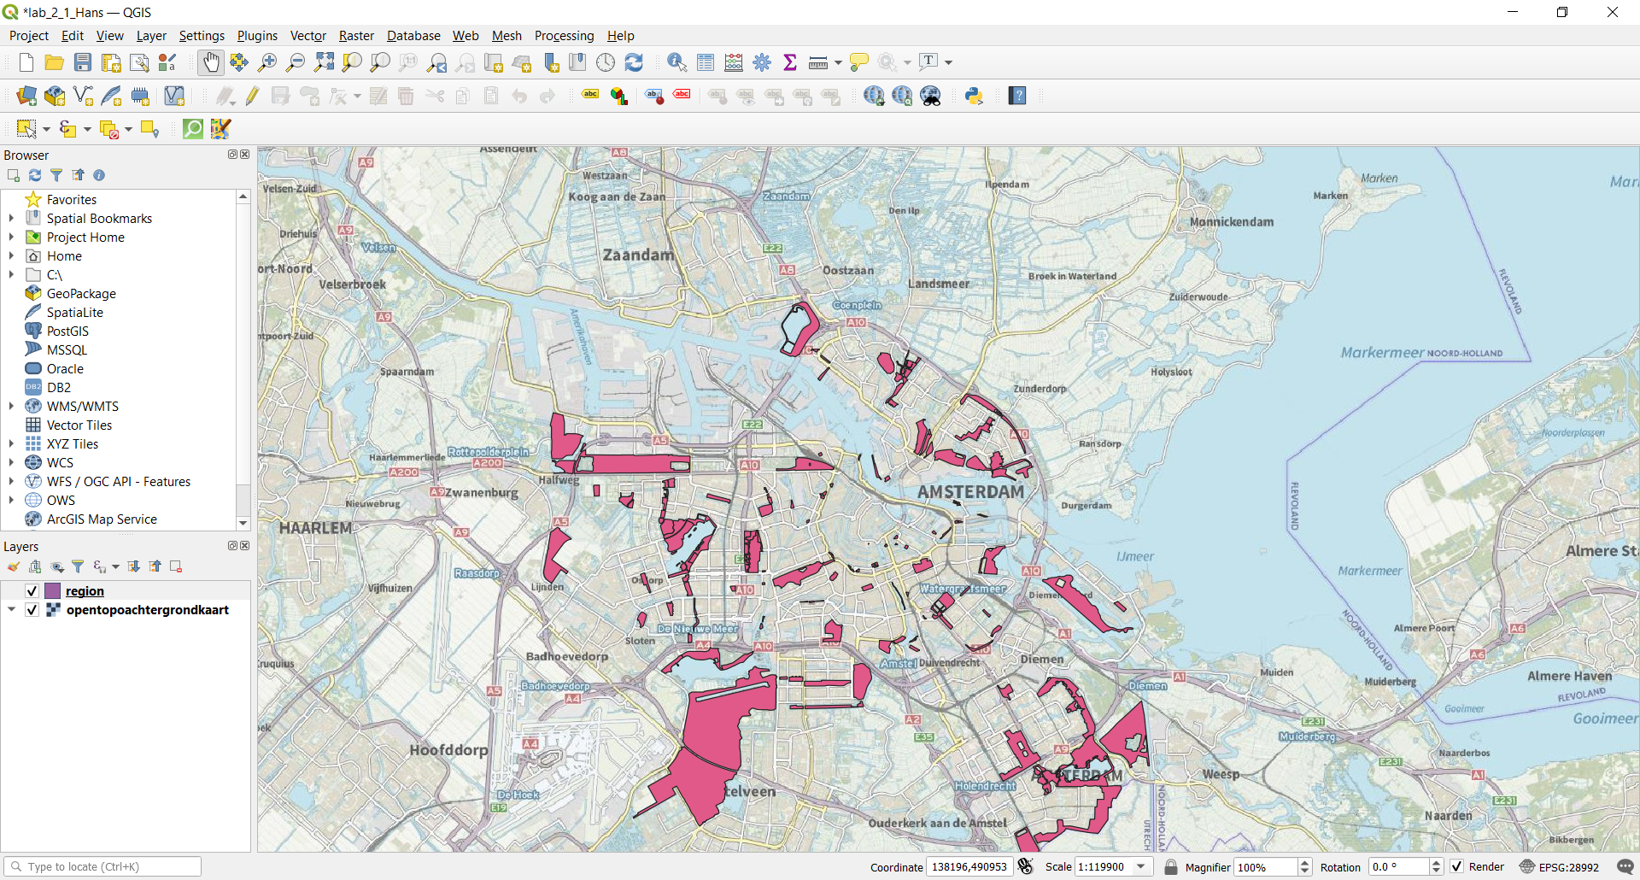

## **Tessellation.**

A specific form of *Region*. Regions are non-overlapping, and fill the entire extent of the dataset without gaps (for example, counties of England). A good example of tessellation is the dataset of Dutch provinces you worked with in Lab 1.1. Dataset of Amsterdam neighborhoods/buurten (<https://maps.amsterdam.nl/open_geodata/?k=198>) is also a tessellation.

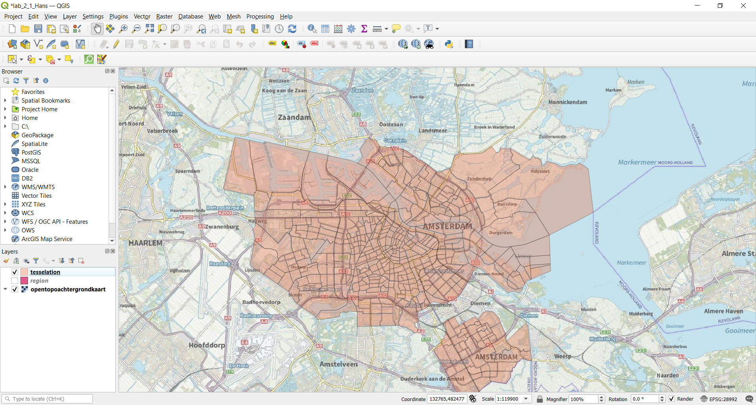

## **Raster.**

A special kind of *Tessellation*, where the regions are all squares (cells). A typical example is satellite imagery. Another example is the digital elevation map of Amsterdam shown below. The dataset can be downloaded from PDOK (<https://www.pdok.nl/geo-services/-/article/actueel-hoogtebestand-nederland-ahn1->). You need to use the *WMS* URI (instructions in Lab 1.1) and import the *ahn1_5m* layer to get the same map as below.

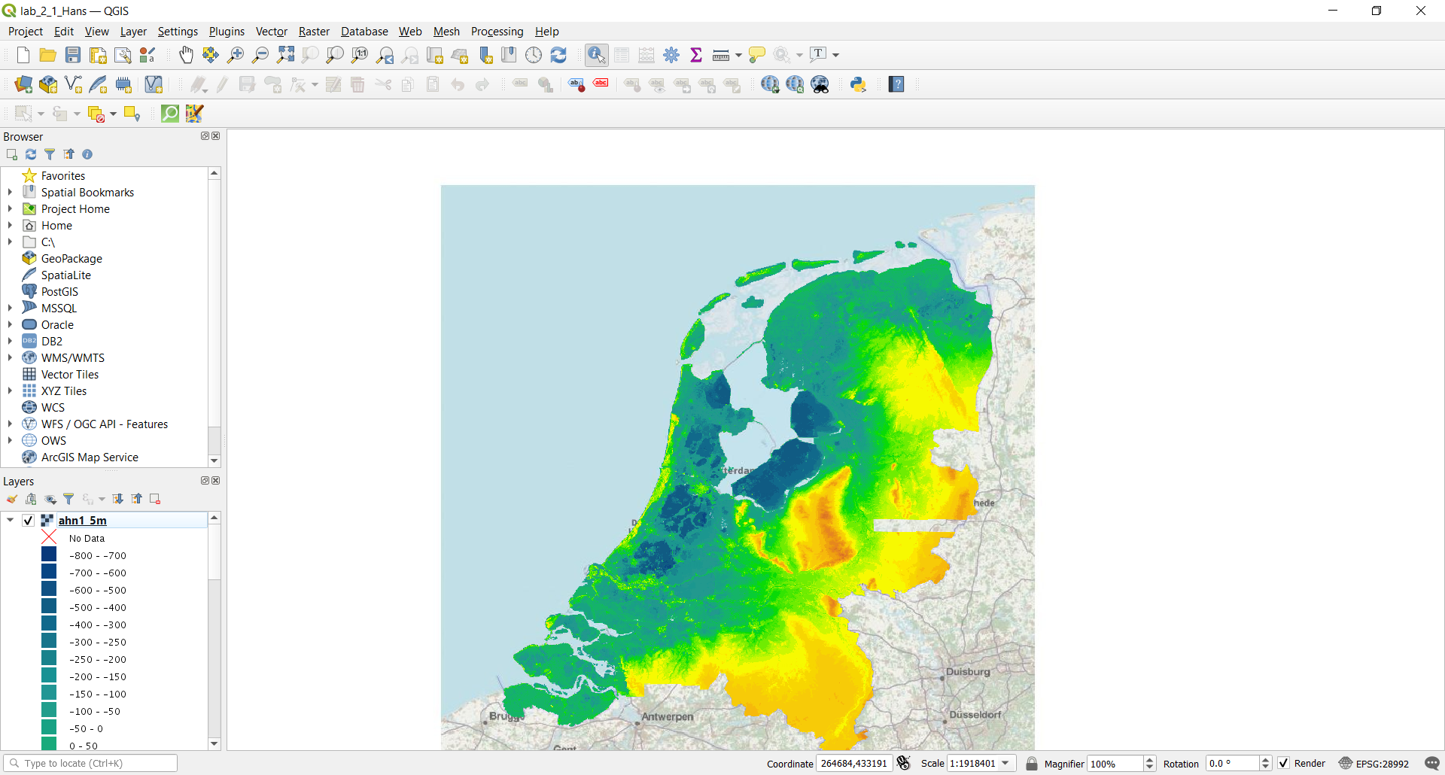

## **Vector Tessellation.**

Any kind of *Tessellation* that is not a *Raster*. Below is an example of *Vector Tessellation* geometry. The map depicts Amsterdam neighborhoods/buurten (<https://maps.amsterdam.nl/open_geodata/?k=198>).

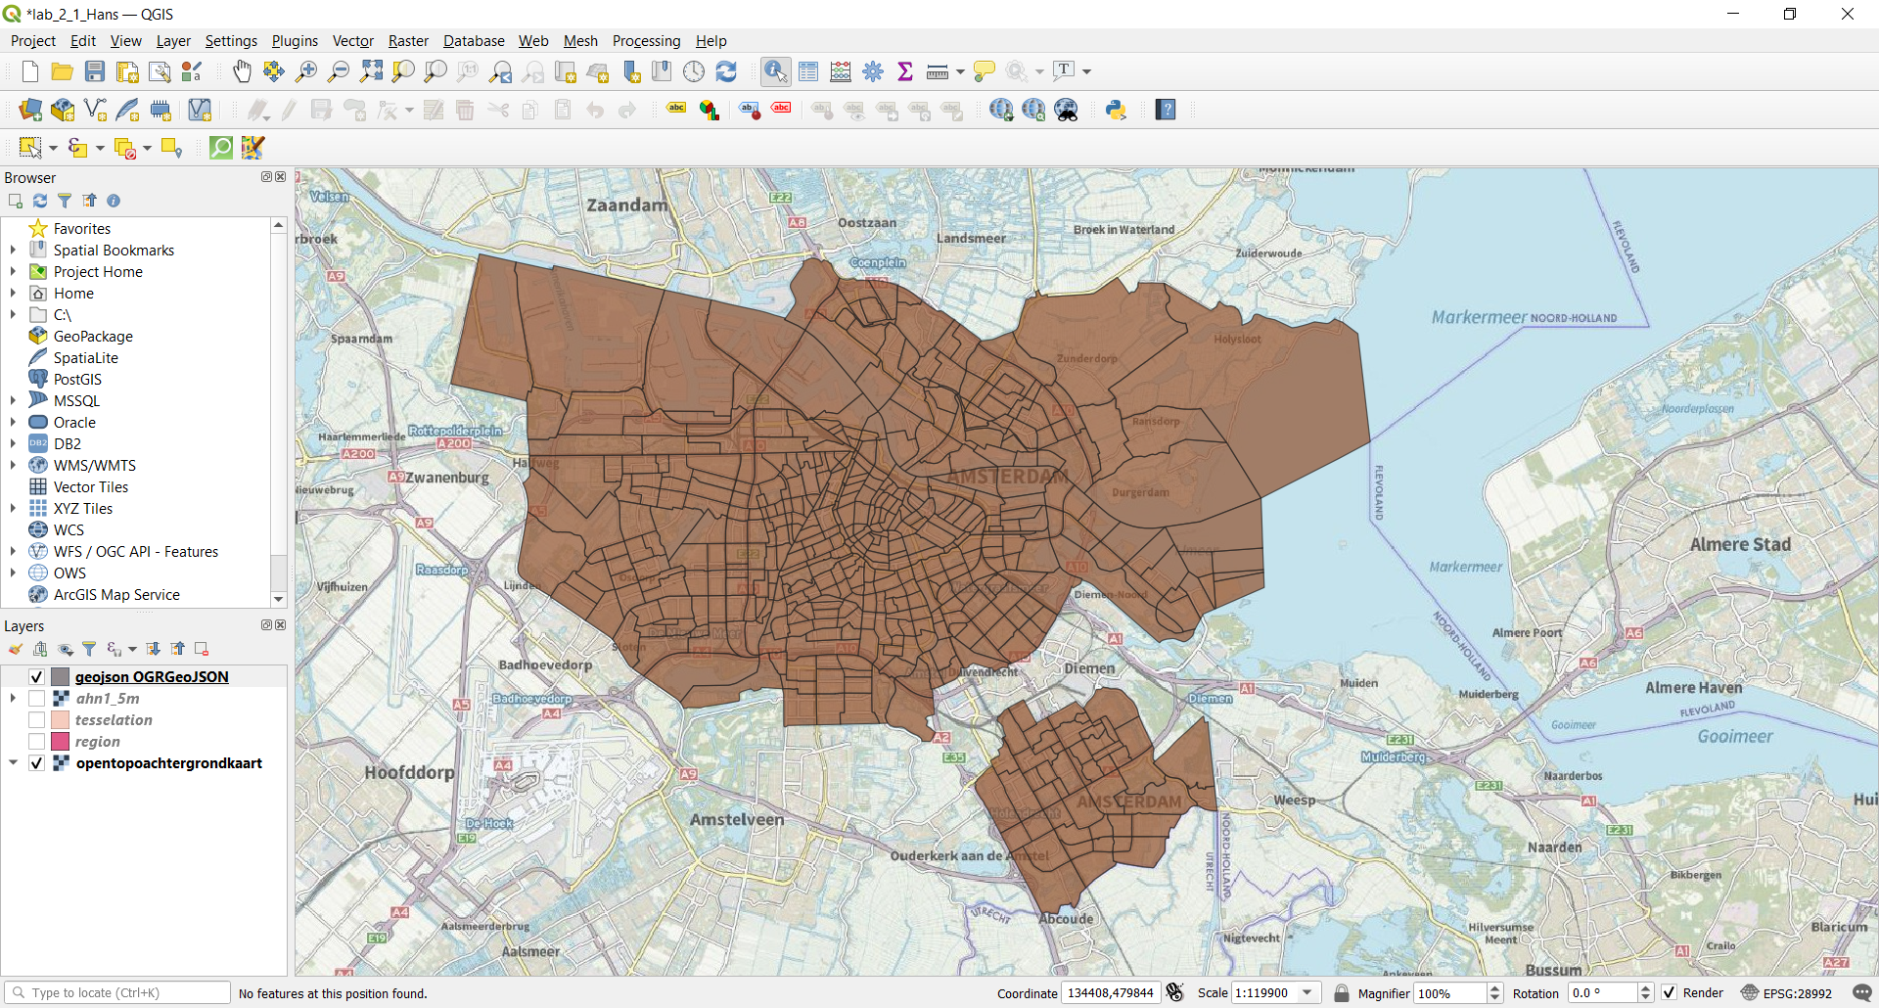

## **Line.**

A dataset where the geometric primitives are lines. The map below depicts Amsterdam streets accessible to pedestrians (<https://maps.amsterdam.nl/open_geodata/?k=298>). Each street section is encoded as a line.

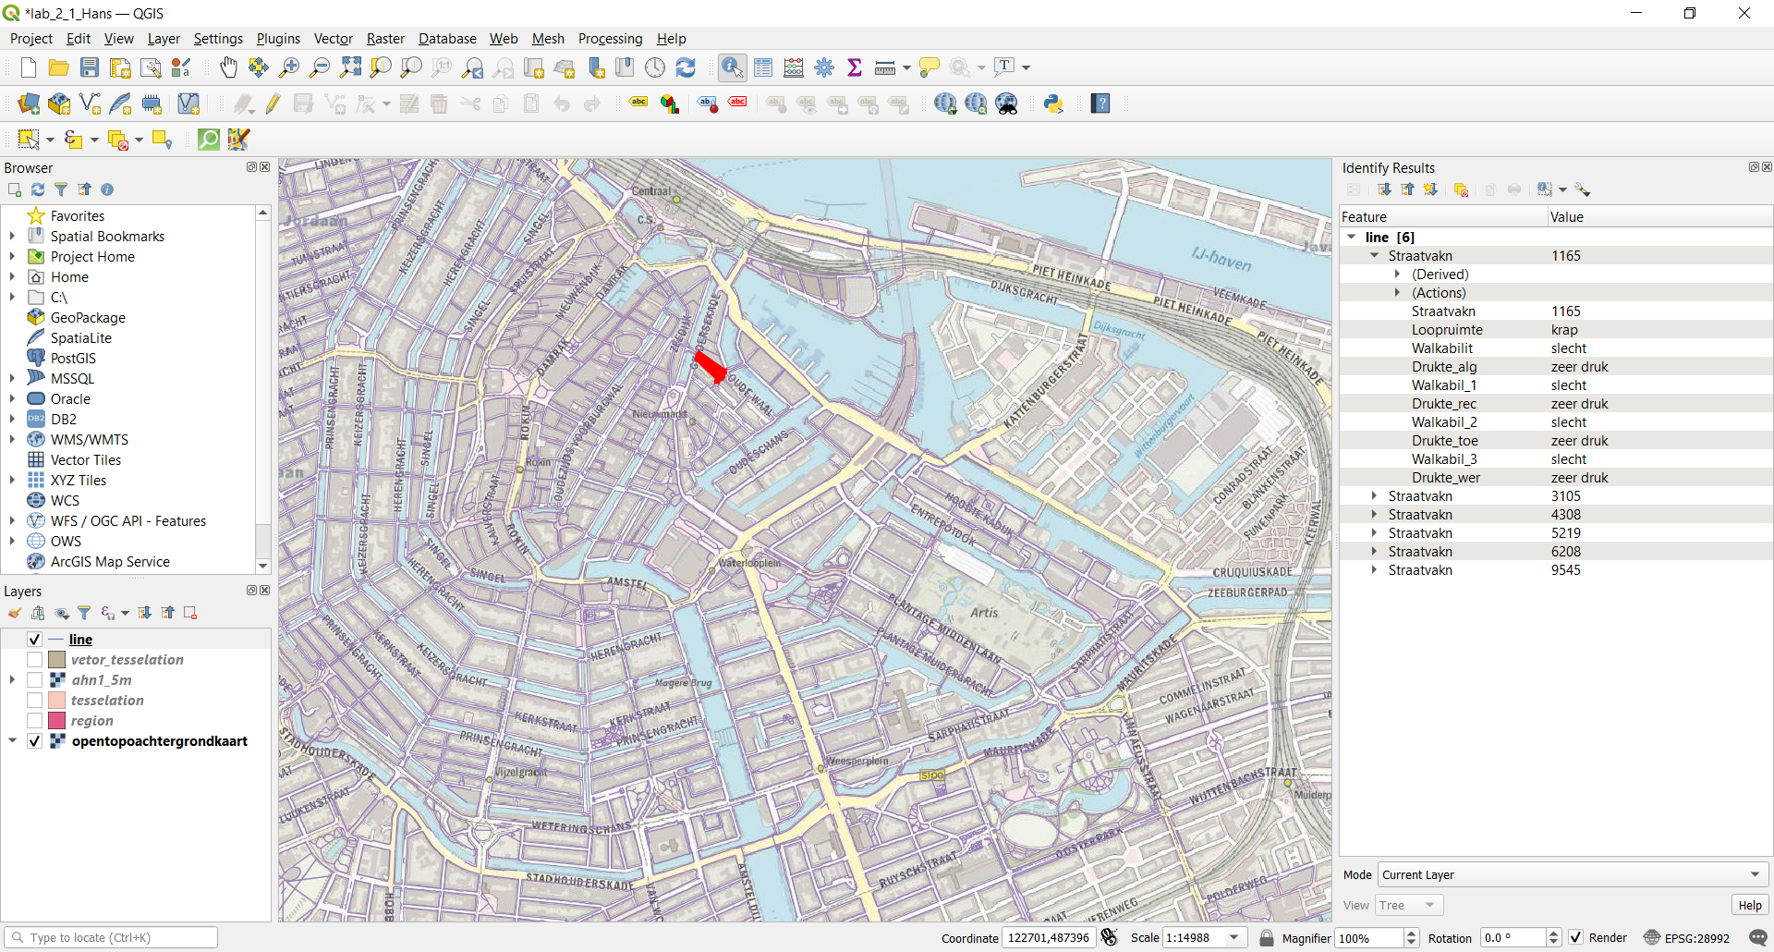

## **Point.**

A dataset where the geometric primitives are points. For example, in Amsterdam geodata portal, youth and student housing in Amsterdam (<https://maps.amsterdam.nl/open_geodata/?k=115>) are depicted with points as shown below.

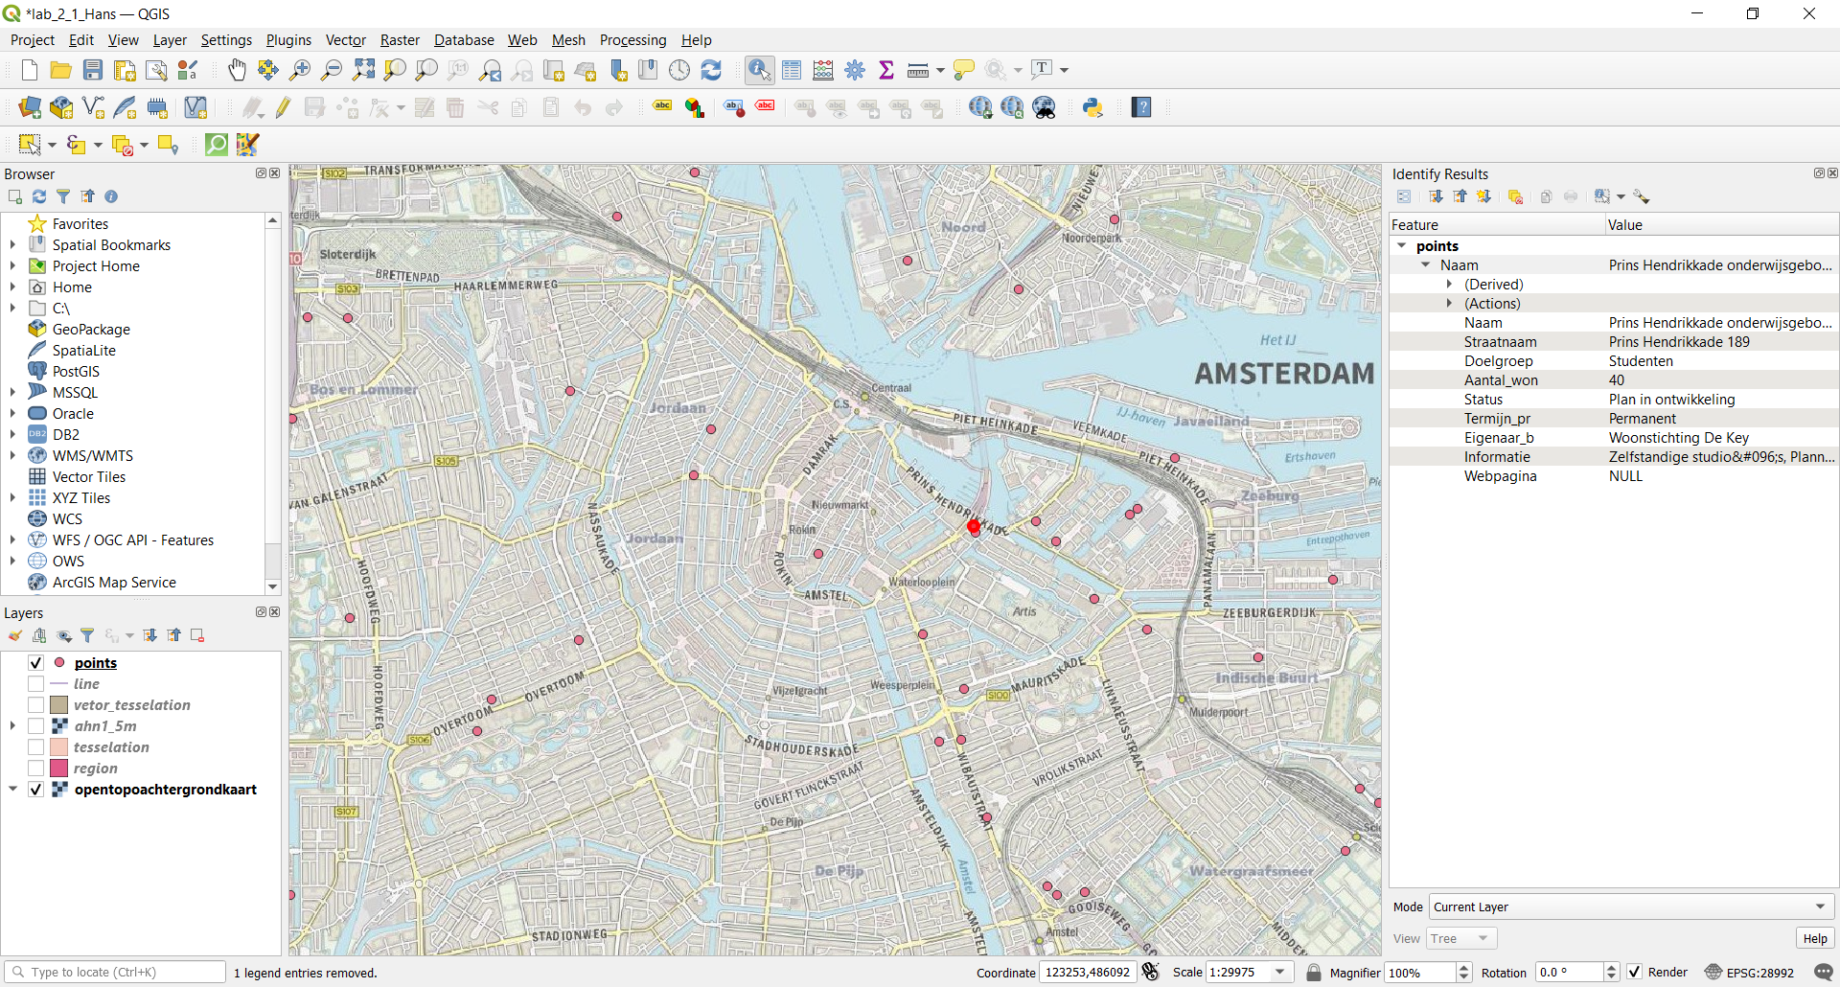

## **Event.**

An event is a thing which happens in time. Events therefore have a start and end time as well as a duration, even if this is not explicitly represented in a dataset. *Event* denotes a dataset **where each data item can be regarded as an event** in this sense. For example: a map layer depicting occurrences of rhinos in South Africa, or house sales in London, or earthquakes in Iceland, or building construction phases in Amsterdam. The map below depicts the categorized events of attacks on Amsterdam during World War 2 (*Soort* attribute, <https://maps.amsterdam.nl/open_geodata/?k=100>).

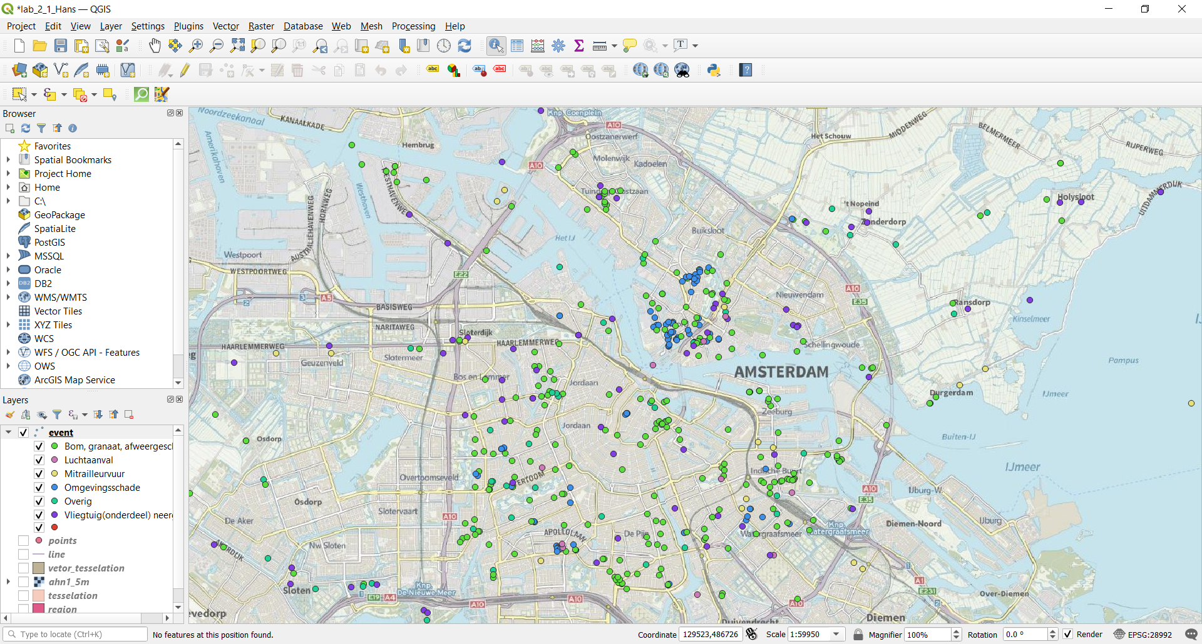

## **Track.**

It is a subtype of *Event*. In *Track* dataset, data items are snapshots of a trajectory of some moving object. For example: a dataset of tracks of birds, where each point is a position of a bird. The map below shows the flight paths of a goose family during a migration (<https://www.movebank.org/cms/webapp?gwt_fragment=page=studies,path=study1049685237>). Note that the map below actually depicts two datasets: a dataset of track points and a dataset of lines connecting the track points.

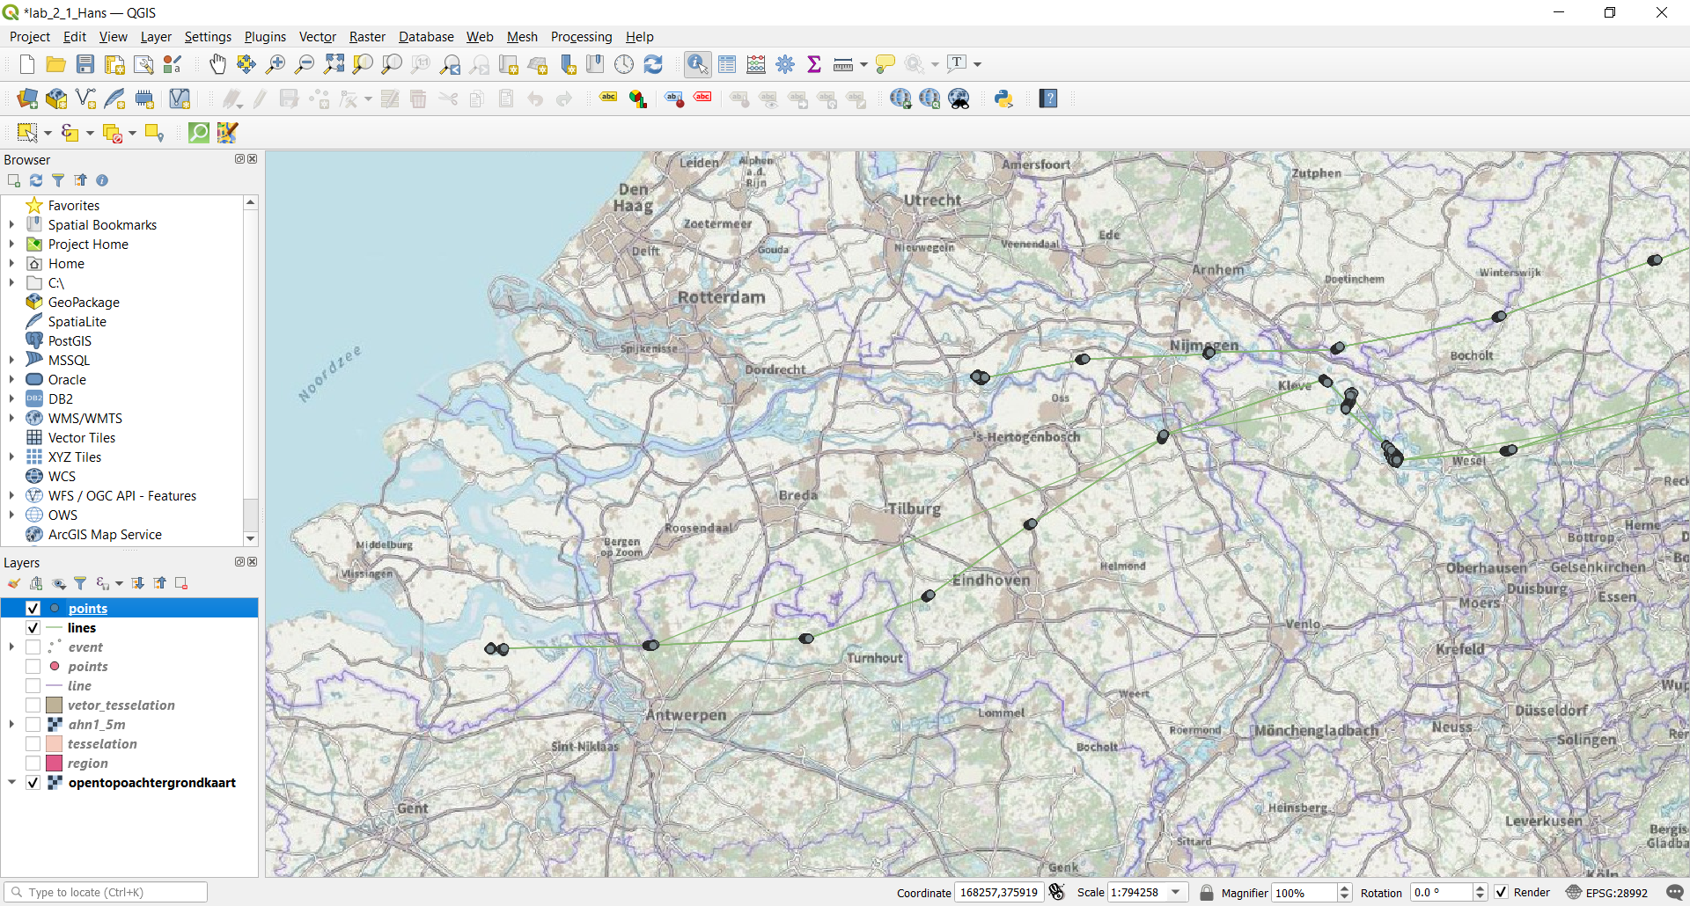

## **Contour.**

*Contour* is a subtype of *Field*. A dataset that represents *Field* by contours. Each contour encloses field values that lie inside a given interval. For example, a terrain contour map or an air pressure map in meteorology. In the image below, there is a contour map of noise levels caused by air traffic around Amsterdam (*KLASSE* attribute, <https://maps.amsterdam.nl/open_geodata/?k=252>).

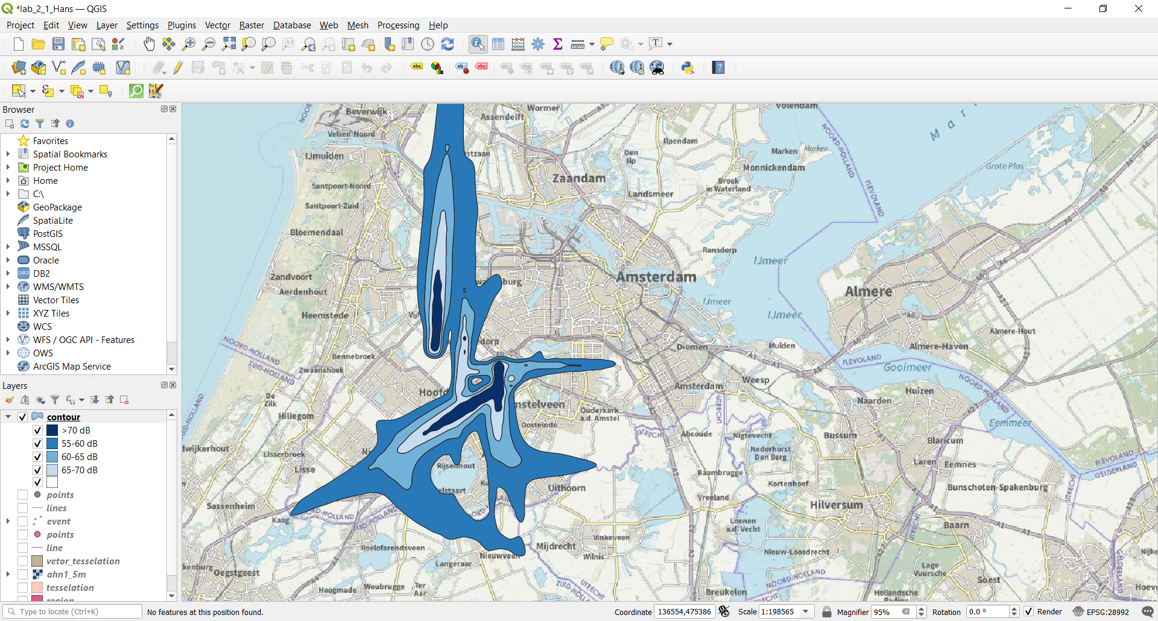

## **Patch.**

*Patch* is a subtype of *Field*. *Patch* is a region dataset that represents irregular patches of a field containing homogeneous field values. For example, the map below visualizes the areas of Amsterdam parks with corresponding levels of restrictions (Off-leash, restricted, prohibited) for dogs (*Soort* attribute, <https://maps.amsterdam.nl/open_geodata/?k=245>).

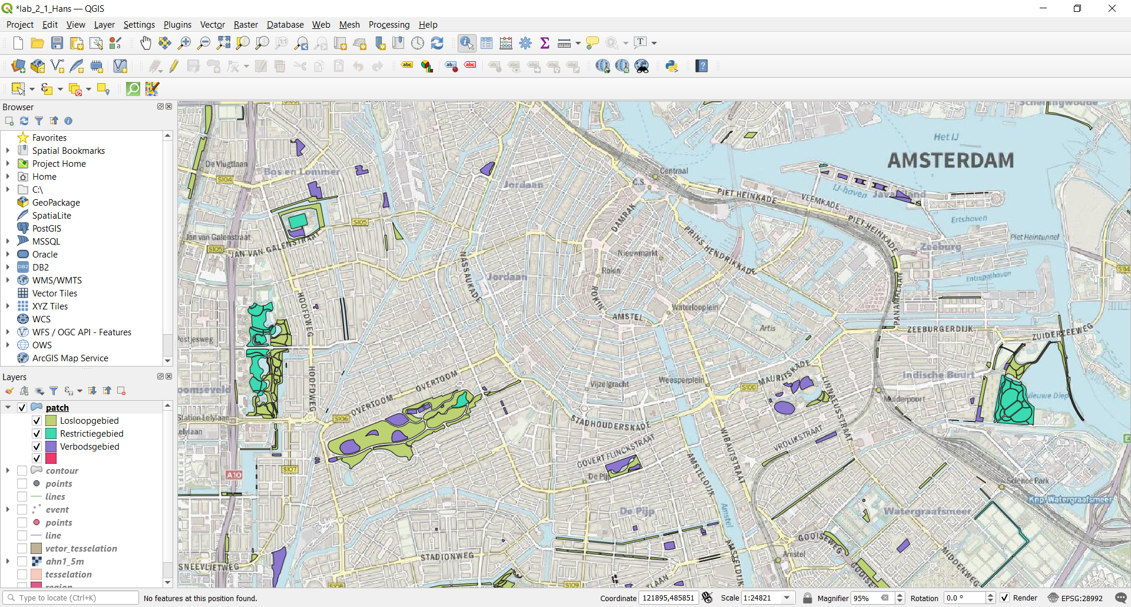

## **Coverage.**

*Coverage* is a subtype of *Field*. Conceptually, *Coverage* is similar to *Patch*. The distinction from *Patch* is that *Coverage* is also a form of *Tessellation*. For example, a dataset describing soil types is *Coverage*. Another example of *Coverage* is the map shown below depicting the landuse types in Amsterdam (*CBScode2_OmsEng* attribute, <https://maps.amsterdam.nl/open_geodata/?k=152>).

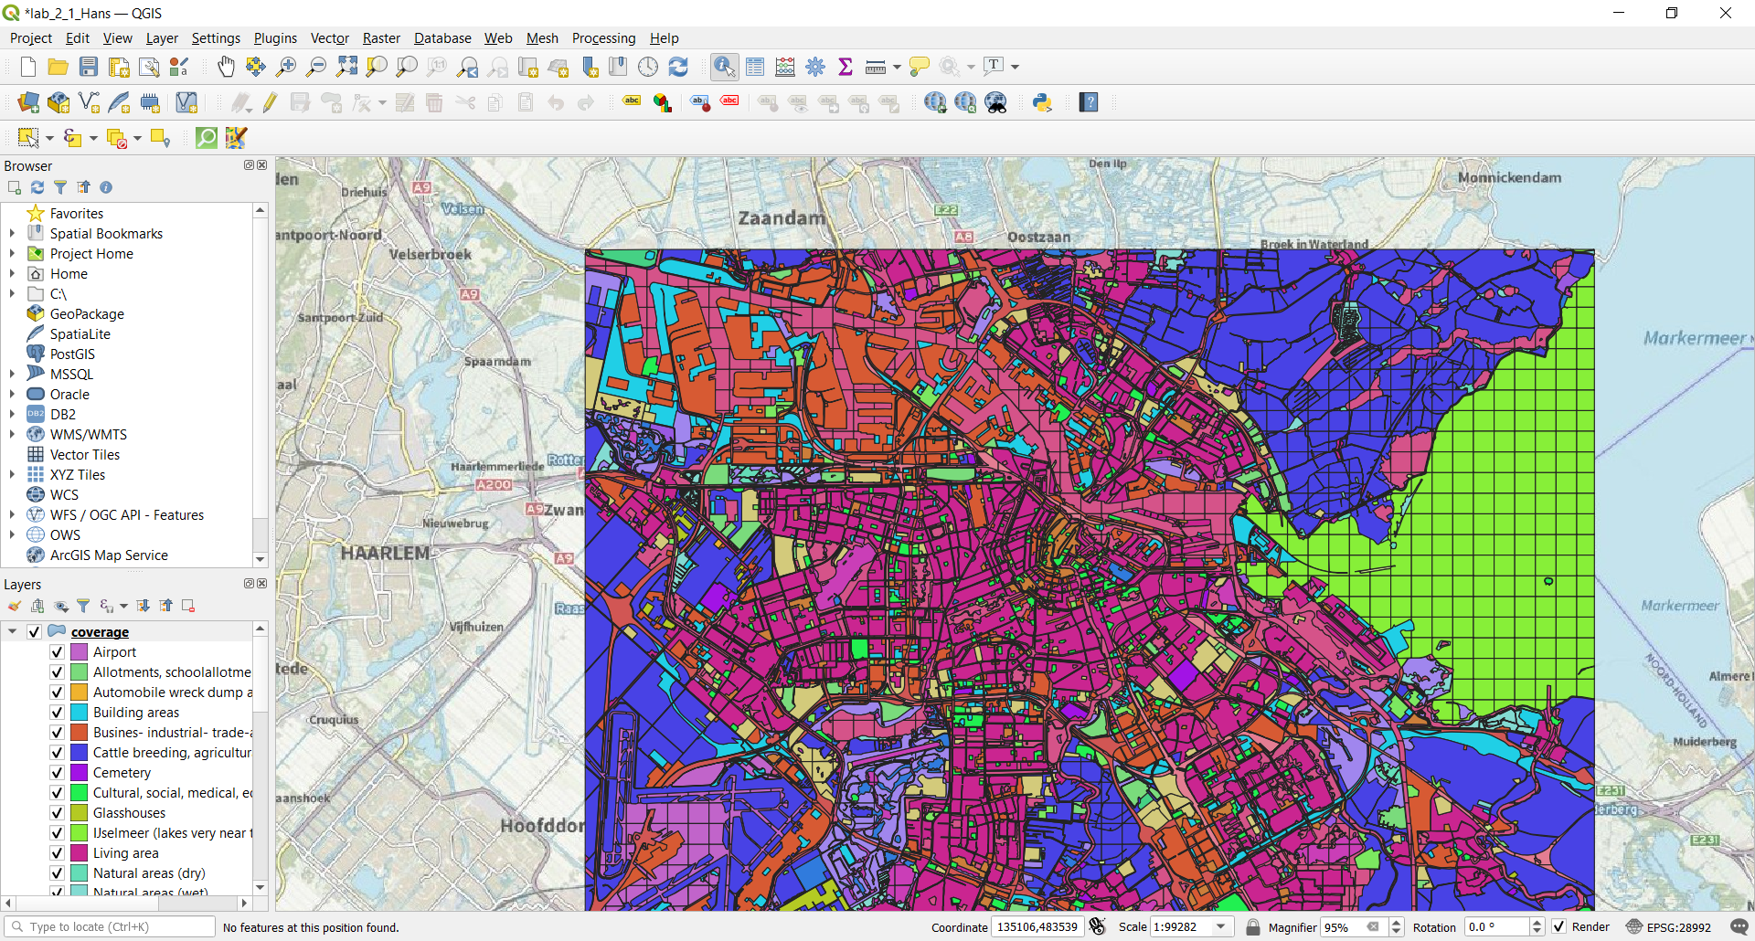

## **Field Raster.**

*Field Raster* is a subtype of *Field*. A dataset representing a field in terms of raster cells. For example, a remote sensing image, where the represented field is light intensity, or a digital terrain model. The previously shown digital elevation map of Amsterdam is also an example of *Field Raster*.

[your dataset screenshot here]

## **Point Measures.**

*Point Measures* is a subtype of *Field*. A dataset representing a field in terms of a sample of point-like measurements. For example, a record of temperature sensor measurements in a city. Another example in the map below are CPT measurements (Geology) to identify soil’s load-bearing capacity in Amsterdam (*Top_Pleistoceen* attribute, <https://maps.amsterdam.nl/open_geodata/?k=243>).

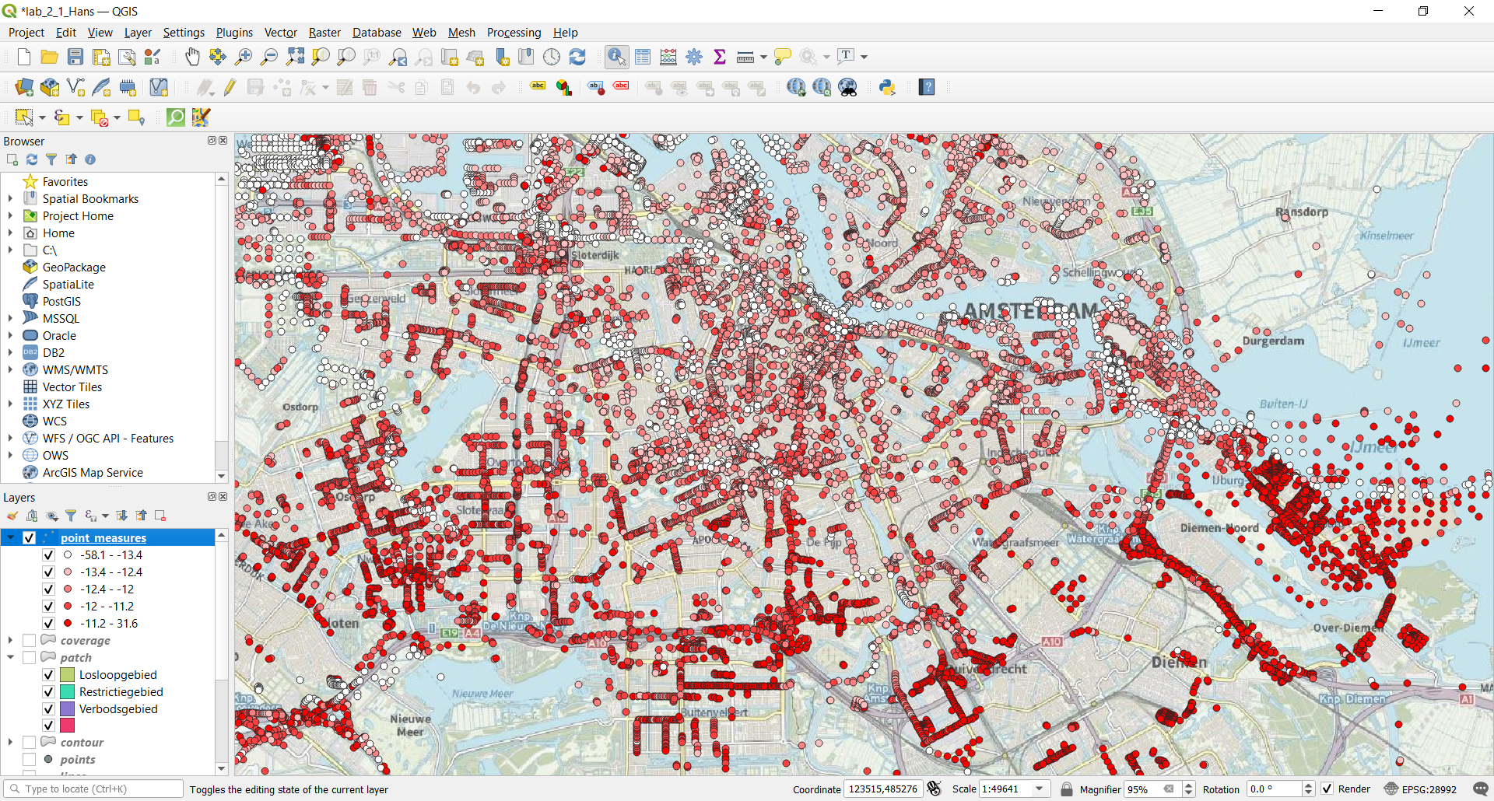

## **Line Measures.**

*Line Measures* is a subtype of *Field*. A dataset representing a field in terms of lines of homogeneous values. For example, *Line Measures* is a coastline, which is a line depicting sea level height as shown in the map below (dark blue line). This dataset is from PDOK (<https://www.pdok.nl/geo-services/-/article/zeegebieden>), and can be downloaded via the WFS server by choosing the *SR.Coastline* layer.

## **Object.**

Objects are things that have a name and are spatially bounded. Their locations are represented for a temporal snapshot. In contrast to events they don’t have a start or end. An *Object* is a dataset **where each data item is a spatial object in this sense**. Compared to *Field*, *Object* is a whole and indivisible entity of its own. Attributes report about qualities of these objects, for example, statues in Groningen, or streets of London. The map below depicts as points the individual trees in Amsterdam (<https://maps.amsterdam.nl/open_geodata/?k=254>).

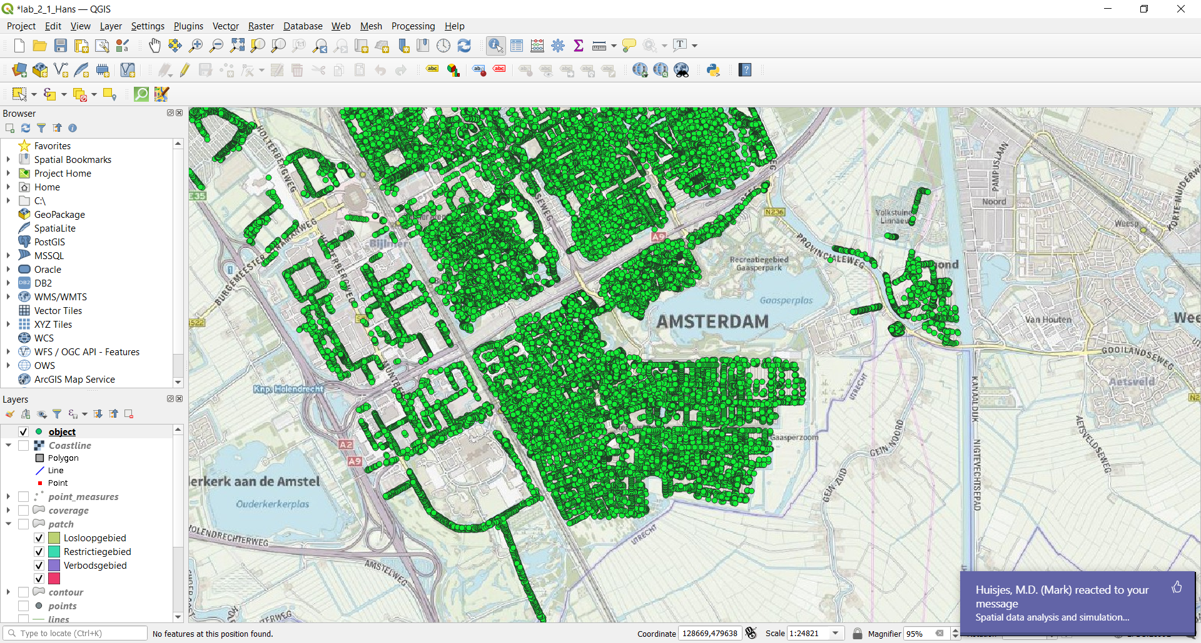

## **Lattice.**

An *Object* which represents statistical areas forming a *Tessellation,* and attributes are spatial summaries. For example, official statistics of the municipalities of the Netherlands. The previously shown map of Amsterdam neighborhoods (<https://maps.amsterdam.nl/open_geodata/?k=198>) is an example of *Lattice*.

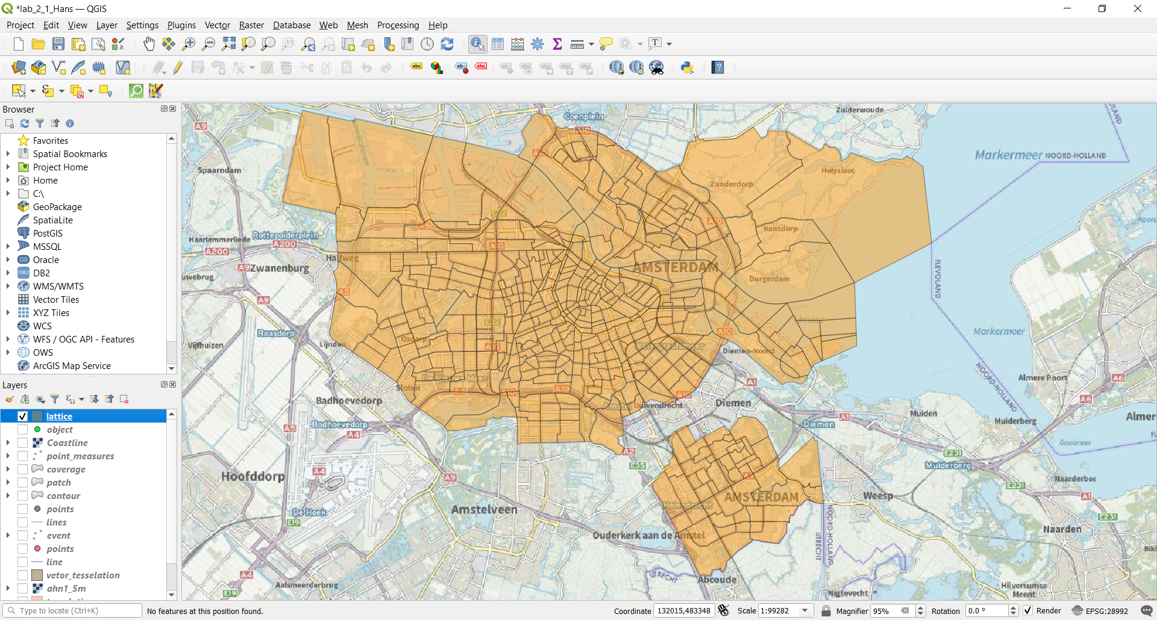

## **Amount.**

A layer where each data item represents an amount of objects or matter, but is itself **not** an object (and therefore the layer is not classified as *Object*). If this is a raster dataset, e.g., then each raster cell represents an amount of objects. For example, the amount of residents living in a cell, or the percentage of elderly. In the example below, each point depicts the number of solar panels (*Gedetecteerde_panelen* attribute) detected at the location and the amount of energy (*Vermogen* attribute) produced by these panels (<https://maps.amsterdam.nl/open_geodata/?k=251>).

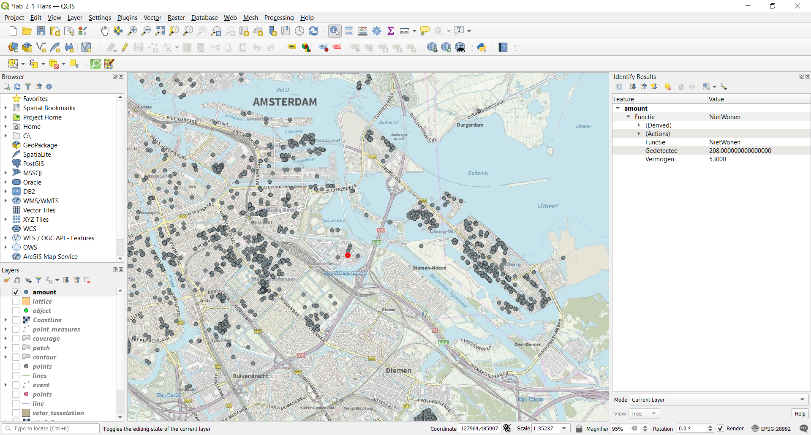

## **Network.**

*Network* is a quantified relation between pairs of spatial objects, for example, traffic flow between two road intersections during rush hour, or commuter flow between municipalities of the Netherlands, or migration flow between cities. *Network* is a dataset that represents the measures of these pairs, either in terms of a linked list or a matrix or an object quality. The map below depicts traffic flows on Amsterdam roads during a 24-hour weekday (*etmaal* attribute, <https://maps.amsterdam.nl/open_geodata/?k=253>).

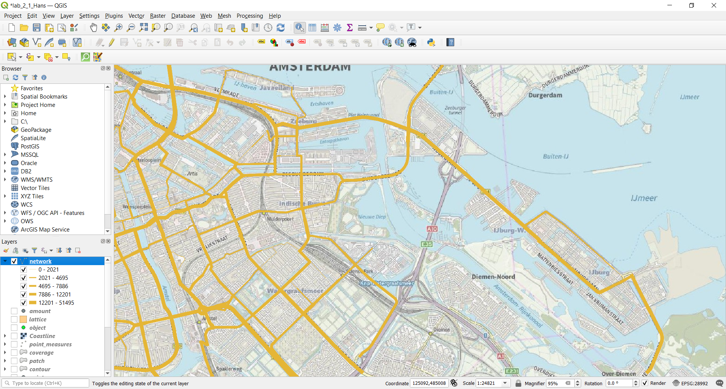

## **Example annotation measurement scales of real datasets**

A dataset about historical buildings of Amsterdam city. The dataset can be found on the open geodata portal of the municipality of Amsterdam: <https://maps.amsterdam.nl/open_geodata/?k=118>.

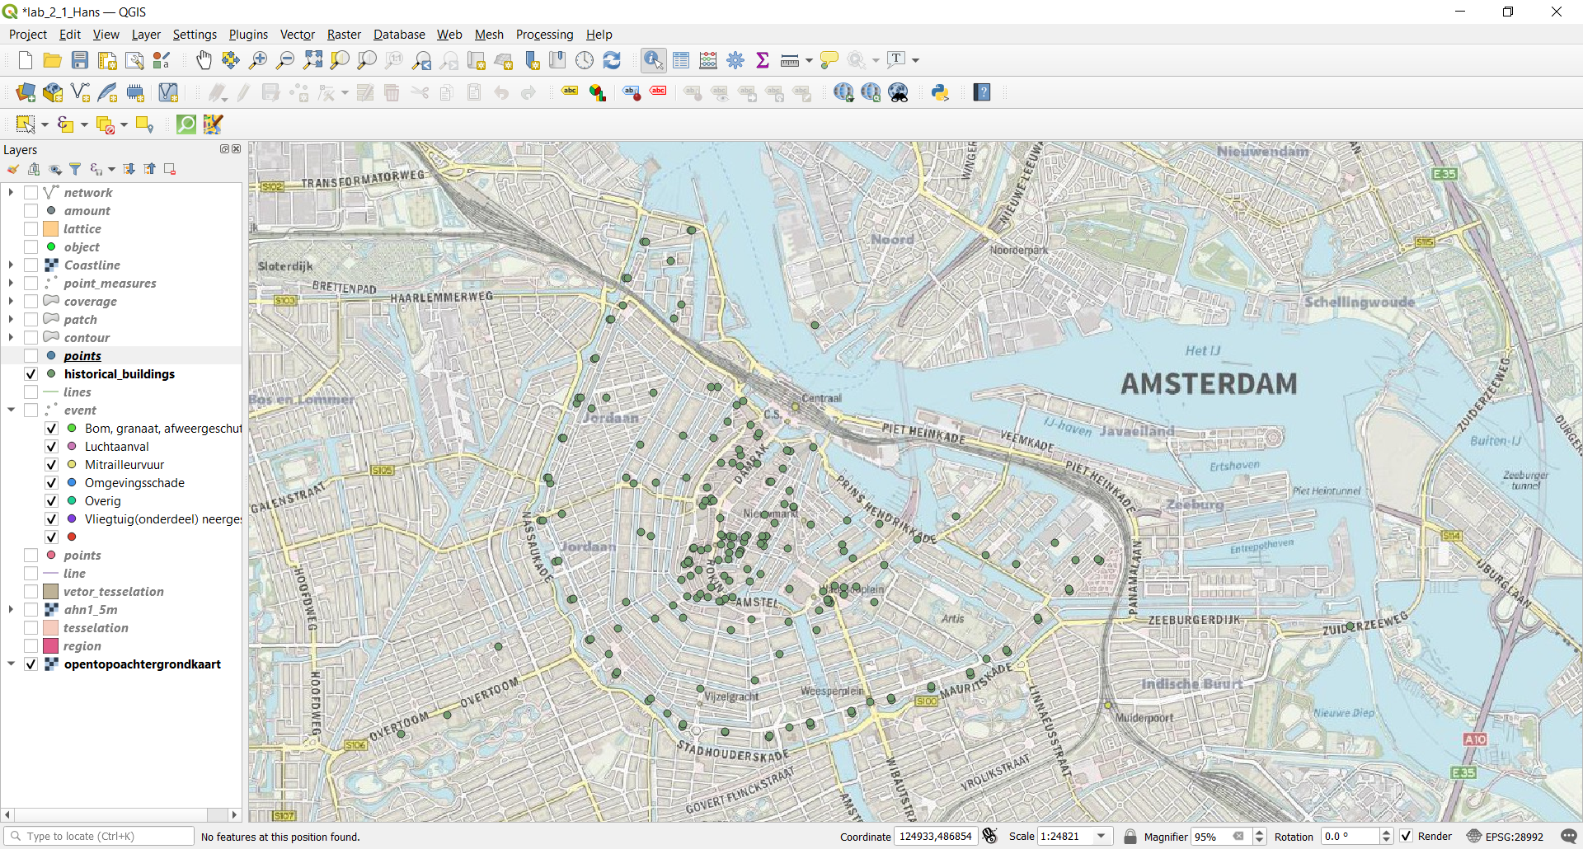

A dataset depicting potential areas for deploying wind turbines around Amsterdam city (<https://maps.amsterdam.nl/open_geodata/?k=96>).

